Physics 30H Lesson 40H Thermodynamics

Note: This subject is covered very well in the textbook by D. C. Giancoli. Therefore, you will do the assigned problems from the Giancoli text book (white copy). As you read you will notice many concepts that you have already dealt with in Chemistry 30.

Heat & Temperature

As familiar as we are with the concepts of heat and temperature, most people do not have a good understanding of what these term actually mean. One thing to note is that you cannot trust your own personal experience with these phenomenon. A common misconception is that your body can “sense” temperature. It can’t! Metals feel colder than wood, even if they are at the same temperature. A -20° C day may be bearable one day, if there is no wind, but seem much colder another day if there is wind (ie: wind chill). Comfortable room temperature is about 20° C, try jumping in a swimming pool also at 20° C and you’ll feel extremely cold.

The problem is that your body actually senses energy transfers, and not temperature directly. Thermal energy is transferred between two objects when they are at a different temperature. The energy that is transferred is called “heat”. If you touch wood at 0° C, heat will flow from your hand to the wood, and you perceive this as “cold”. If you touch metal at 0° C, heat will again flow, but at a greater rate because metal is a better thermal conductor than wood. You perceive this greater transfer as “colder” even though it is really the same temperature. The sum of all the energy of all the molecules in an object is called its internal energy, sometimes called its thermal energy.

Zero^{th} Law of Thermodynamics

Two objects allowed to exchange thermal energy are said to be in “thermal contact” (they need not be touching). Heat will flow as long as the temperatures are different. When heat stops flowing, the objects are said to be in “thermal equilibrium”, and therefore at the same temperature. The Zero^{th} law of thermodynamics got its unusual name because it seemed too obvious to even officially state as a law. ( the 1st and 2nd laws were created before the zero^{th} until it was realized that this law was needed before the 1st law could be proven).

The zero^{th} law simply states:

“If two systems are in thermal equilibrium with a third system, then they are in thermal equilibrium with each other.”

This makes temperature a useful concept, as it means that if object A and B have reached thermal equilibrium, and B is also in contact with C then A and C must also be in thermal equilibrium. We can now say that all things at the same temperature will be in thermal equilibrium with each other.

Temperature Scales

A number of different scales have been devised to describe temperature. We are most accustomed to using the Celsius scale that is based around the melting point (0° C) and the boiling point (100° C) of water. Other scales doe exist however and are commonly used for various applications.

Farenheit
The Farenheit scale is predominantly used in the United States to describe temperatures and is still used in the medical profession to determine temperatures of patients. 0°C corresponds to 32°F and every 1° C = 9/5° F. To convert from Farenheit to Celsius do as follows:
Example: Normal body temperature is 98.6°F. What is this in celsius?

98.6°F is (98.6 – 32) = 66.6°F above the freezing point of water.
(Since each °F is equal to 5/9 of a °C then:)
66.6 x 5/9 = 37.0 °C

The Kelvin
Introduced by the Scottish physicist William Thompson (Lord Kelvin, 1824 –1907), the Kelvin (K) is the SI base unit for temperature. The size of one Kelvin is identical to that of one degree Celsius, because there are one hundred divisions between the ice and steam points on both scales. The difference between the Kelvin scale and the Celsius scale is the zero points. The lowest temperature is defined as the zero point on the Kelvin scale (referred to as absolute zero) occurs at –273.15° C on the Celsius scale. Thus the Kelvin temperature (T) and Celsius temperature (T_{c}) scales are related by:

T = T_{c} + 273.15

The concept of absolute zero is better understood by examining the Kinetic Theory of matter.

Kinetic Theory

The Kinetic Theory is one of the building blocks of modern science. It is the idea that matter is made up of little pieces called atoms which are continually moving around. The kinetic Theory can explain much about matter and its properties, including Boyle’s Law (pressure and volume are inversely related) which we will study in more detail in Fluid Dynamics. The Kinetic Theory also gives us insight into what temperature really is:
Temperature is a measure of the average kinetic energy of the particles that make up matter.

E_{K} = ½ mv² = 3/2 kT (k = 1.38 x 10⁻²³ J/K, “Boltzmann’s constant”)

(An important thing to realize about this equation is that we cannot find the actual speed of an individual molecule, or even the average speed of the molecules. Only the v_{rms} can be obtained.)
Example: What is the average kinetic energy of molecules in a gas at 37° C?

(First we must convert 37° C to Kelvin.)

T = T_{c} + 273.15 = 37 + 273.15 = 310.15 K

E_{K} = 3/2 kT = 3/2 (1.38 x10⁻²³ J/K)(310.15 K) = 6.42 x 10⁻²¹ J

Thermal Expansion

Linear Expansion
Most substances expand when heated and contract when cooled (save for water). However, the amount of expansion and contraction depends on the type of material. Experiments indicate that the change in length (ΔL) is, to a good approximation, directly proportional to the change in temperature (ΔT) of the object. The change in length is also proportional to the original length of the object (L_{o}). That is, for the same temperature change, a 4 m long iron rod will increase twice as much in length as a 2 m long iron rod. These proportionality’s can be combined in the equation:

ΔL = αL_{o}ΔT (where α, is the coefficient of linear expansion)

The values for α for various materials at 20 °C can be found in the table below.
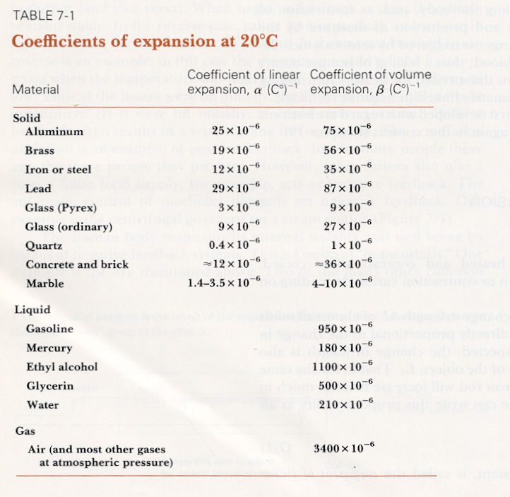
Example: A railroad track of steel is 200 m long at 20°C and must remain in contact with the adjacent track for obvious reasons. If the track is exposed to temperature extremes of -30°C to +40°C, how much space should the track be given to expand and contract? (i.e. How much will the track change in length?)

@ 40°C ΔL = (12 x10⁻⁶/°C)(200)(40°C - 20°C) = 4.8 x 10⁻² m = 4.8 cm

@ -30°C ΔL = (12 x10⁻⁶/°C)(200)(-30°C - 20°C) = -1.2 x 10⁻² m = 12 cm

The total length change of the track will be 16.8 cm.

Volume

The change in volume of a material which undergoes a temperature change is given by a relation that is similar to the linear expansion equation.

ΔV = βV_{o}ΔT where: ΔT = change in temperature
V_{o} = original volume
β = coefficient of volume expansion
Note that the linear expansion has no meaning for liquids and gasses since they do not have a fixed shape. However if a liquid is contained (i.e. thermometer), the β will be nearly equal to α. (See table above.)

Example: A 70-liter tank of a car is filled to the top with gasoline at 20°C. The car is then left out in the sun and the tank reaches a temperature of 50°C. How much gasoline do you expect to overflow from the tank?

ΔV = βV_{o}ΔT
= (9.5 x 10⁻⁴/°C)(70L)(30°C)
= 2.0 liters

Calorimetry

Back when temperature and heat were not well understood, the calorie (cal) was introduced as being the official unit of heat, where one calorie was the amount of heat needed to raise the temperature of one gram of water from 14.5°C to 15.5°C. Now that we know that heat is energy, the calorie is not needed anymore as the joule can be used. 1cal is the same as 4.186 J of energy which is known as the “mechanical equivalent of heat”.

As you are well aware, however, the calorie is still very much in use. A Cal (capital C) is sometimes called a food calorie is actually 1000 cal (kilocalorie) and is often misused as the equivalent of the cal. (Think about this next time you have a McDonalds burger Jack!)

Recall that, temperature is a measure of the average kinetic energy of the molecules of an object. Heat specifically refers to energy that has been from one object to another as a result of a temperature difference. Note that the kinetic theory explains this nicely as the collisions between fast (hot) and slow (cool) molecules.

The sum of all the energy of all the molecules in an object is called its internal energy, sometimes called its thermal energy. Note that thermal energy depends on two things:

- How many molecules (moles)and object contains
- How hot (temperature) it is.

Specifically: U_{th} = 3/2NkT =3/2 nRt N = number of molecules
n = number of moles

Heat Capacity and Calorimetry

The temperature of an object will rise when you add heat (energy) to it. The amount of heat (Q) required to raise the temperature of a system is found to be proportional to the mass (m) of the system and to the change in temperature (ΔT) of the system. This is expressed in the equation:
Q = mcΔT (where c = specific heat capacity)

The equation above is useful for relating additions of heat with temperature changes, and is particularly useful for calorimetry, which is the quantitative measurement of heat exchange. One important use of the calorimeter is the measurement of specific heats of substances. It is very important that the calorimeter is well insulated so that only a negligible amount of heat is lost to the environment.

Latent Heat

Adding heat to a substance does not always result in a temperature change. At certain critical temperatures, the addition or removal of heat can lead to a change in phase of the material. The equation Q=mcΔT is valid only for regions where a phase change does not occur. At the point of phase change, additional energy must be added (or released depending on direction – solid to liquid or vice versa). Latent heat () is the term used to describe the extra quantity of heat involved in the phase change. is defined as being the amount of heat per unit mass involved in the phase change. This means that:

Q = m where: _{F} = latent heat of fusion (solid / liquid)
_{V} = latent heat of vaporization (liquid / gas)
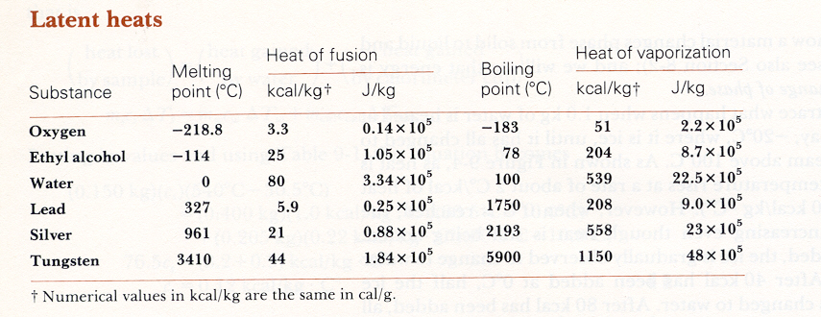
Example
How much energy does a refrigerator have to remove from 1.5 kg of water at 20°C to make ice at -12°C?

Q = mcΔT + m_{F} + mcΔT

= (1.5 kg)(1.0 kcal/kg)( 20°C) + (1.5 kg)(80 kcal/kg) + (1.5 kg)(0.50 kcal/kg)( 12°C)

= 160 kcal or 6.7 x 10⁵ J

Heat Transfer: Conduction, Convection Radiation

Heat can be transferred from one place to another in primarily three different ways:

Conduction: As the name implies it is the transfer of heat by contact. It is similar to electric current, however, whereas current has electrons that move from one object to another, thermal conduction has only thermal energy flowing from one place to another. Conduction can be visualized as the result of molecular collisions (kinetic theory).

Convection: Convection means that thermal energy is being carried by particles (molecules, electrons,…) while these particles are moving. For example, heat is transferred from the element to pasta in a pot by convection. Water is heated at the bottom of the pot (conduction). The heated water then rises, carrying thermal energy to the top of the pot, and to the pasta (convection).

Radiation: Convection and conduction require the presence of matter. Yet all life on earth depends on the transfer of energy from the sun which must traverse empty space. This form of energy transfer is heat and is referred to as radiation. Basically, all “hot” objects
(above 0 K) emit electromagnetic radiation. All objects around you are “hot” (yes even Jack!), and emit EMR. This light is not in the visible range, but rather the infrared. It is in the infrared that most of the suns energy is transferred to the Earth.

The First and Second Laws of Thermodynamics

Thermodynamics is the study of transfers of energy by work and heat. Work is a mechanical transfer of energy ( a force through a distance), while heat is a transfer of energy due to temperature difference. In discussing thermodynamics we shall often refer to a particular system. A system is simply a collection of objects. Everything else in the universe is called the “environment”. There are several kinds of systems:

Closed: only energy, not matter are exchanged within the system

Open: matter and energy are able to be exchanged within the system

Isolated: nothing is exchanged within the system

Most systems we study in Physics are closed systems.

The First Law of Thermodynamics

The first Law of thermodynamics is really a statement of the Law of Conservation of Energy. It says that the net change of internal energy for any system depends on two things:
- the amount of work done
- the amount of heat transferred

This makes sense because these are the only two ways in which energy can be transferred. The outcome of Joule’s experiments is that experimentally it is always found that the change in internal energy of a closed system (ΔU) is given by the equation:
ΔU = Q – W where: Q = heat added to the system
W = the work done by the system

The difficulty arises in assigning a (+ or -) value to the values.

- If work is done on the system, W will be negative (therefore ΔU will increase)
- If heat leaves the system, Q is negative

As far as systems go, are primarily interested in systems which consist of ideal gasses. Gasses can be changed in any of three ways:

1) heated or cooled (changed in temperature)
2) expanded or contracted (changed in volume)
3) increased or decreased in pressure

We categorize these changes into “processes”.

Process | Condition
Isothermal | Temperature remains constant (W=Q)
Adiabatic | Heat is not exchanged with environment (Q = 0) so (ΔU = -W)
Isobaric | Pressure is kept constant
Isochoric | (Isovolumetric) Volume is held constant (W = 0)
Calculating Work

It is often valuable to calculate the work done in a process. If the pressure is kept constant during the process (isobaric), the work done by a gas is easily calculated using:
W = Fd

If the force is just the pressure (P) of the gas times the area (A) then:

W = (PA)d

And area (A) times distance (d) is volume (V), then

W = PΔV
Example
An ideal gas is compressed at a constant pressure of 2.0 atm (2.0 x 10⁵ N/m²), from 10.0 liters to 2.0 liters. Assuming the process is Isothermal, calculate the total work done in the process and the heat flow into the gas.

W = PΔV = (2.0 x 10⁵ N/m²) (2.0 x 10⁻³m³ - 10.0 x 10⁻³m³) = -1.6 x 10³ J

Isothermal means that the temperature remains constant. Since the temperatures at the beginning and end of the process are the same, there is no change in internal energy, thus, ΔU = 0. Therefore:

Q = W = -1.6 x 10³ J

Second Law of Thermodynamics

The Second Law of Thermodynamics is a law describing that some things never happen, even though they would not violate any other laws of physics if they were to occur. It is a statement about which processes occur in nature and which do not.

The First Law of thermodynamics is a statement of the law of conservation of energy. There are, however, many instances we can imagine that conserve energy but do not occur in nature. For example, consider what happens as you drop a rock and it hits the ground. The initial potential energy of the rock is converted to kinetic as the rock falls. Upon impact with the ground, the kinetic energy is converted to thermal energy and the molecules in the vicinity of the impact move slightly faster causing the ground to heat up. Have you ever seen the reverse happen – a rock at rest on the ground suddenly rise into the air because the thermal energy of the molecules is transformed into kinetic energy of the rock as a whole? Similarly, when a hot object is placed in contact with a cold object, heat flows from the hotter one to the colder one, never the reverse. If heat were to leave the colder and move to the hotter, energy would still be conserved, but it does not happen. This lack of reversibility led scientists to formulate a new principle, the Second Law of Thermodynamics. One aspect of this statement as given by R.J.E. Clasius is
“Heat flows naturally from a hot object to a cold object; heat will not flow naturally from a cold object to a hot object.”
Heat Engines

The development of this statement of the second law was based partly on the study of heat engines.

A heat engine is any device that converts thermal energy into mechanical work. (i.e. steam engine)

A heat engine extracts thermal energy from a hot object (cooling it somewhat in the process) and transforms it into mechanical energy. It is important to understand that heat engines operate at two temperatures: a “high” and a “low” temperature. This is essential, as it is the lowering of the temperature (from high to low) which is used to do work. Since energy is conserved the relationship:

Q_{H} = W + Q_{L} or W = Q_{H} - Q_{L}

where: Q_{H} = energy at hot temperature
Q_{L} = energy at low temperature
W = mechanical work / energy released

The efficiency of a heat engine is a measure of how good it is at “squeezing the energy out” of a hot object. It is defined a s the ratio of (how much work is done) to (how much heat energy there is).

e = W/Q_{H}

but recall, W = Q_{H} - Q_{L}
e = 1- Q_{L}/Q_{H}
therefore, e = Q_{H} - Q_{L} / Q_{H} or (x 100 for %)

It is clear from this equation that the efficiency will be greater if Q_{L} can be made small. Clearly a perfect engine would extract all the thermal energy out of a hot material, and use it to do work. But this would leave the material at absolute zero, which is a theoretical impossibility itself. This leads to another statement of the 2nd law.

No device is possible whose sole effect is to transform a given amount of heat completely into work. A 100% efficient (perpetual) machine is impossible.

Carnot Engines

In the early 19th century, a French engineer N.L. Carnot studied in detail the process of converting heat into mechanical energy. He realized that not all of the extracted thermal energy can be used to do work. Some of the energy will be lost in the engine, and reappear as heat (due to friction, turbulence, etc…). He reasoned that an idealized engine would have none of these real life problems, and is thus given the name the Carnot engine.

A Carnot engine would take material at a high temperature (T_{H}) and cool it to a low temperature (T_{L}). For this “perfect” engine, the efficiency can be found in terms of temperature (T) as opposed to energy (Q).
e_{Carnot} = 1- T_{L}/T_{H}
(x 100 for %)

Note that even for the Carnot engine, the efficiency is not 100% as T_{L} cannot be 0. The Carnot efficiency is the best possible efficiency for a given set of operating temperatures. In fact a well designed, real engine performs at about 60 to 80 percent of the Carnot efficiency.

Example
A steam engine operates between 500°C and 270°C. What is the maximum possible efficiency of this engine?

First we must convert T to Kelvin.
T_{L} = 270 + 273.15 = 543.15 K
T_{H} = 500 + 273.15 = 773.15 K

e_{Carnot} = 1- T_{L}/T_{H}

e = 1-(543.15 / 773.15) = 0.30

e = 30 % (maximum or Carnot efficiency)

Entropy

The Second Law of Thermodynamics has evolved over the centuries. In the 19th century it was finally stayed in a general fashion that applied to all aspects of the law.

Natural processes tend to move toward a state of greater disorder.

When a hot object is put in contact with a cool one, heat flows from the high to the low until the two objects reach the same intermediate temperature. At the beginning of the process, we can distinguish two separate classes of molecules: those with high E_{K}, and those with low E_{K}. After the process , all the molecules are in one class with the same E_{k} and we no longer have the same orderly arrangement of molecules. Thus disorder has increased.

The natural process is from a state of order to disorder. An unbroken glass is more orderly than the pieces of a broken one. Glasses break when they fall, but do not spontaneously mend themselves. Again, disorder has increased.

In the late 1860’s, Clausius introduced a concept known as entropy. Entropy is a quantitative measure of the disorder of a system. If heat is added to an object its entropy increases. Increasing the thermal energy of an object represents an increase in the disordered motion of the molecules. Removal of heat from a body represents a decrease in entropy.

According to Clausius, the change in entropy (S) of an object when an amount of heat (Q) is added to it by a reversible process at a constant temperature (T) in Kelvin is given by:
ΔS = Q /T

While it is possible that in a given process the entropy of a system can decrease, if this happens, the entropy of the surroundings increases by a greater amount. Overall, it can be shown that the net increase in entropy is greater than the decrease in entropy, and the entropy of the universe continually increases.

Heat Death

A prediction of the second law of thermodynamics is that as time goes on, the universe will approach a state of maximum disorder. Matter will become a uniform mixture, heat will have flowed from high to low temperature regions until the whole universe is one temperature. No work can be done. All the energy of the universe will have become degraded to thermal energy and all change will cease! (Assuming we live in a finite, static universe, of course…)

Hand-in Assignment

Part A

1. Do #1, 3 to 8 on page 205.

2. An aluminum rod is 15.0 m long at 20ºC. If the extremes of temperature it will face are -20ºC and 50ºC, how much will it expand and contract? (α_{aluminum} = 2.5 x 10⁻⁵ ºC⁻¹)

3. A cylindrical container has a radius of 10 cm. 25 L of water is poured into the container. What is the initial height of the water at 20ºC? The water is allowed to sit in the sun until it reaches a temperature of 45ºC. Assuming that none of the water evaporates, what is the new height of the water in the cylinder? (β_{water} = 2.10 x 10⁻⁴ ºC⁻¹)

4. Compare and contrast heat, temperature, thermal energy and internal energy.

5. Do #1 to 13 on pages 270 and 271.

6 An ideal gas is compressed at a constant pressure of 3.0 atm from 15.0 L to 3.0 L. (In the process, heat flows out and the temperature drops.) Holding the volume constant, heat is then added to the gas until the temperature rises back to the original temperature. The total process is shown as BDA in Figure 10-4 on page 252.
A. Calculate the work done by the gas.
B. Calculate the heat flow into the gas.

- A steam engine operates between 550ºC and 230ºC. Calculate the maximum efficiency of the engine.

- A 50.0 kg sample of water at 18ºC is mixed with 50.0 kg of water at 26ºC. Calculate the resulting change in entropy of the universe.

Part B

1. A steel measuring tape was calibrated at 20ºC. At 40ºC will it read high or low and what is the % error? (α_{steel} = 1.2 x 10⁻⁵ ºC⁻¹)

2. An iron sphere is 28 cm in diameter. What will be it’s change in volume if heated from 20ºC to 200ºC?

3. When 539 kcal of heat is added to 1.0 kg of water at 100ºC it is changed to steam at 100ºC. If 1 cal = 4.19 J and 1 kg of steam occupies 1.63 m³ at 100ºC and 1 atm:
A. Calculate the work done if the pressure is 1.0 atm.
B. Calculate the change in internal energy of the water.

4. An ideal gas expands adiabatically to twice its volume. In doing so the gas does 850 J of work.
A. How much heat flowed into the gas?
B. What is the change in internal energy of the gas?
C. Did its temperature rise or fall?

5. An ideal gas expands at a constant pressure of 7.0 atm from 280 mL to 630 mL. Heat then flows out of the gas at constant volume and the pressure and temperature are allowed to drop until the temperature reaches its original value.
A. Calculate the work done by the process.
B. Calculate the total heat flow into the gas.

6. What is the maximum efficiency of a heat engine with operating temperatures of 480ºC and 318ºC?

7. A heat engine produces 9.50 kJ of heat while doing 2.50 kJ of useful work. Calculate its efficiency.

8. An engine operates at ½ its theoretical efficiency between temperatures of 545ºC and 310ºC while doing useful work at a rate of 1.0 MW. How much heat is released to the surroundings in one hour?

9. Calculate the increase in entropy if 1.0 kg of water is heated from 0ºC to 100ºC.

