Math 10

Lesson 2–3 Answers
Lesson Questions
Question 1
If possible, factor each trinomial.
a) x² + 5x + 6 b) x² – 29x + 28 c) x² – 3xy – 18y²
two factors of –18 that add up to –3
–6(3) = –18
–6 + 3 = –3

x² – 3xy – 18y²
= x² – 6xy + 3xy – 18y²
= (x² – 6xy) + (3xy – 18y²)
= x(x – 6y) + 3y(x – 6y)
= (x – 6y) (x + 3y)

two factors of 28 that add up to –29
–1(–28) = 28
–1 + –28 = –29

x² – 29x + 28
= x² – 28x – x + 28
= (x² – 28x) + (– x + 28)
= x(x – 28) – 1(x – 28)
= (x – 28)(x – 1)

two factors of 6 that add up to 5
3·2 = 6
3 + 2 = 5

x² + 5x + 6
= x² + 3x + 2x + 6
= (x² + 3x) + (2x + 6)
= x(x + 3) + 2(x + 3)
= (x + 3)(x + 2)

Question 2
If possible, factor each trinomial
a) 2x² + 7x – 4 b) –3s² – 51s – 30 c) 3x² + x – 4
3·–4 = –12
two factors of –12 that add up to 1
–3(4) = –12
–3 + 4 = 1

3x² + x – 4
= (3x² – 3x) + (4x – 4)
= 3x(x – 1) +4(x – 1)
= (x – 1) (3x + 4)

2·–4 = –8
two factors of –8 that add up to 7
–1(8) = –8
–1 + 8 = 7

2x² + 7x – 4
= (2x² + 8x)+ ( –x – 4)
= 2x(x + 4) –1 (x + 4)
= (2x – 1) (x + 4)

1st there is a GCF of –3
–3(s² + 17s + 10)

two factors of 10 that add up to 17
Not possible!

–3s² – 51s – 30
= –3(s² + 17s + 10)

Question 3
If possible, factor each trinomial
a) x² + 7x + 10 b) 6x² – 5xy + y² c) 2y² + 7xy + 3x²
two factors of 6 that add up to 7
6(1) = 6
6 + 1 = 7

2y² + 7xy + 3x²
= (2y² + 6xy) + (xy + 3x²)
= 2y(y + 3x) + x(y + 3x)
= (2y + x)(y + 3x)

two factors of 6 that add up to –5
–2(–3) = 6
–2 + –3 = –5

6x² – 5xy + y²
= (6x² – 2xy) (– 3xy + y²)
= 2x(3x – y) – y(3x – y)
= (2x – y)(3x – y)

two factors of 10 that add up to 7
2(5) = 10
2 + 5 = 7

x² + 7x + 10
= (x + 2) (x + 5)

Note: for any equation
ax² + bx + c, if a = 1 we do not have to decompose, we can write the factored form directly!! Check it out!!

Assignment

1. a) x² + 4x + 3; (x + 1)(x + 3)
b) x² + 2x + 1; (x + 1)(x + 1)
c) x² + x – 2; (x + 2)(x – 1)
d) x² + 5x + 4; (x + 4)(x +1)

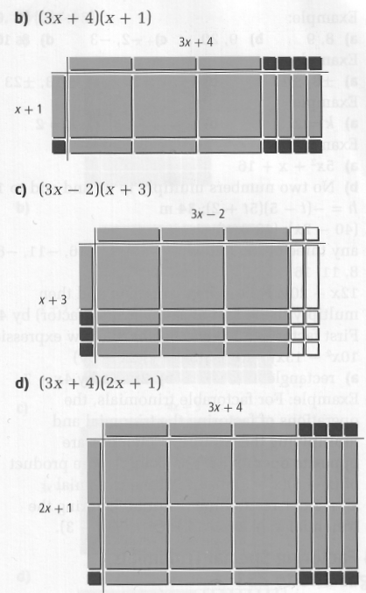
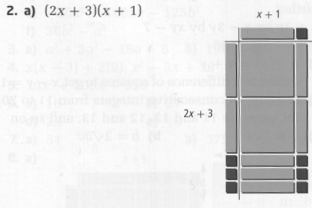

3. a) (x + 2)(x + 5)
b) ( j + 3)(j + 9)
c) (k + 4)(k + 1)
d) not factorable
e) (d + 6)(d + 4)
f) not factorable

4. a) (m – 5)(m – 2)
b) (s + 5)(s – 2)
c) (f – 6)(f – 1)
d) (g – 7)(g + 2)
e) (b – 4)(b + 1)
f) 2(r – 3s)(r – 4s)

5. a) (2x + 5)(x + 1) b) (3y + 8)(2y + 1)
c) (3m + 4)(m + 2) d) not factorable
e) (4q + 3)(3q + 2) f) (3x + y)(x + 2y)

6. a) (4x – 3)(x – 2) b) not factorable
c) (x – 2)(x – 3) d) (2m – 3)(m + 3)
e) 3(2x + y)(x – y) f) (4y – 1)(3y + 1)
g) (6c – 5d)(c + 2d) h) (k + 3)(4k + 3)
i) (a + 3b)(a + 8b) j) (6m + n)(m + 2n)

7. a) x + 10 and x + 8; 25 cm by 23 cm
b) 3x + 8 and 2x – 1; 53 cm by 29 cm

8. h = –(t – 5)(5t + 2); 34 m

9. First factor out 3. Then, factor the new expression 10x² – 13xy – 3y²
3(5x + y)(2x – 3y)

10. h = –16(t – 10)(t + 1); 465 ft

