Chemistry 20 – Lesson 13
Intermolecular forces
/38

1. Using the data from the Boiling Point Vs Number of electrons (Noble gases) table, plot a graph of boiling point versus number of electrons for the noble gases.
Boiling point as a function of the number of electrons
–50

–100
–150

–200

–250

–300

0
10
20
30
40
50
60
70
80
# of electrons
Boiling point (ºC)
•
•
•
•
•

/4

2. State a generalisation relating London dispersion forces to the number of electrons in atoms or molecules. Explain the generalisation in terms of Ar, boiling point
–186 ºC, and F₂, boiling point –188 ºC.

/2 In general, the strength of the London dispersion force is proportional to the number of electrons that a molecule or atom has. In other words, the greater the number of electrons, the greater the London dispersion forces. Since Ar and F₂ are isoelectronic (i.e. they have the same number of electrons) they have similar London dispersion forces. Therefore their boiling points are very similar.

3. Both Kr (boiling point, –152 ºC) and HBr (boiling point, –67 ºC) are isoelectronic (have the same number of electrons). Explain what factors could affect intermolecular bonding to cause the difference in boiling points between Kr and HBr.

/2 Kr is nonpolar and HBr is polar. Since they are isoelectronic their London dispersion forces are similar, but the polarity of HBr gives it an extra dipole-dipole force which gives it a higher boiling point.

4. The boiling point of Cl₂ is –35 ºC and the boiling point of C₂H₅Cl (monochloroethane) is 13 ºC. Does the explanation proposed for Question 3 apply here? Explain.

/2 Both Cl₂ and C₂H₅Cl have 34 electrons, but C₂H₅Cl is polar and Cl₂ is nonpolar. Therefore, like question 3, since they are isoelectronic their London dispersion forces are similar, but the polarity of C₂H₅Cl gives it an extra dipole-dipole force which gives it a higher boiling point.
Refer to the following graphs to answer questions 5, 6 and 7 below.

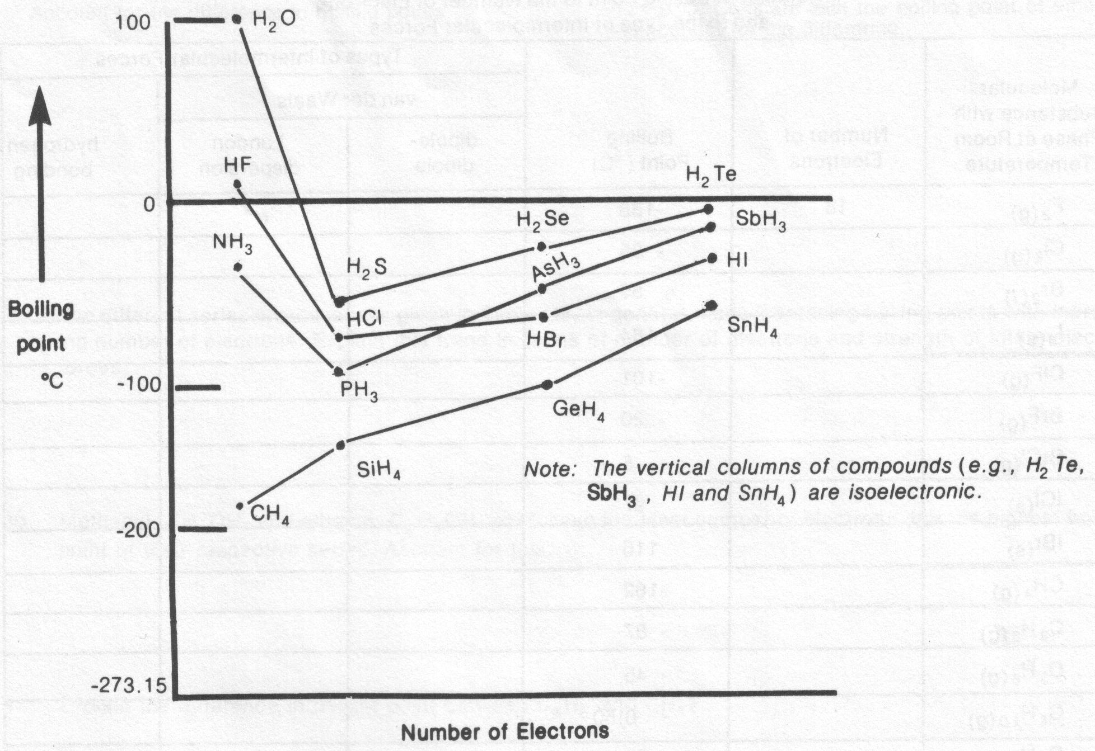

5. The hydrogen compounds of Groups VA, VIA and VIIA elements have consistently increasing van der Waals forces (except for the first hydrogen compounds) with increasing number of electrons. Explain why the boiling point of the first hydrogen compounds of Groups VA, VIA and VIIA elements display a reversal in trend.

/2 H₂O, HF and NH₃ all have hydrogen bonds which has a much greater effect on their boiling points than London dispersion or dipole-dipole forces.

6. Explain why CH₄, the first member of the Group IVA hydrogen compounds, does not show the reversal in trend displayed by the first hydrogen compound of the other elements.

/2 CH₄ is nonpolar (no dipole-dipole forces) and it does not involve hydrogen bonding. Therefore, only London dispersion forces are active.

7. The boiling points of the hydrogen compounds of the Group IVA elements are consistently lower than the boiling points of the other hydrogen compounds. Give a reason for this effect.

/2 The group IVA elements form non-polar molecules, therefore they do not have the extra dipole-dipole forces that other compounds display.
Complete the following table. The first is given as an example. Note that there are six series or groups of molecules.
/8
Molecular substance with phase at room temperature | Number of Electrons | Boiling Point (ºC) | Types of Intermolecular Forces
 |  |  | van der Waals |  | hydrogen bonding
 |  |  | dipole-dipole | London disp.
e.g. – F_{2 (g)} | 18 | –188 |  | √
Cl_{2 (g)} | 34 | –35 |  | √
Br_{2 (l)} | 70 | 59 |  | √
I_{2 (s)} | 106 | 184 |  | √
ClF_{(g)} | 26 | –101 | √ | √
BrF_{(g)} | 44 | –20 | √ | √
BrCl_{(g)} | 52 | 5 | √ | √
ICl _{(s)} | 70 | 97 | √ | √
IBr_{(s)} | 88 | 116 | √ | √
CH_{4 (g)} | 10 | –162 |  | √
C₂H_{6 (g)} | 18 | –87 |  | √
C₃H_{8 (g)} | 26 | –45 |  | √
C₄H_{10 (g)} | 34 | –0.50 |  | √
C₅H_{12 (l)} | 42 | 36 |  | √
CF_{4 (g)} | 42 | –129 |  | √
CCl_{4 (l)} | 60 | 77 |  | √
CBr_{4 (s)} | 146 | 189 |  | √
CH₃F _{(g)} | 18 | –78 | √ | √
CH₃Cl _{(g)} | 26 | –24 | √ | √
CH₃Br _{(g)} | 44 | 3.6 | √ | √
CH₃I _{(l)} | 62 | 43 | √ | √
CH₃OH _{(l)} | 18 | 65 | √ | √ | √
C₂H₅F _{(g)} | 26 | –38 | √ | √
C₂H₅Cl _{(g)} | 34 | 13 | √ | √
C₂H₅Br _{(l)} | 52 | 38 | √ | √
C₂H₅I _{(l)} | 70 | 72 | √ | √
C₂H₅OH _{(l)} | 26 | 78 | √ | √ | √
Use the preceding table to answer Questions 8 to 14.

8. Compare the boiling points of BrF_{(g)} and C₃H₈ _{(g)}. Account for the difference in boiling points.

/2 BrF has more electrons than C₃H₈ and BrF is polar while C₃H₈ is nonpolar. BrF has a higher boiling point since it has larger London dispersion forces and also has dipole-dipole forces acting.
9. Dimethyl ether, CH₃OCH_{3(g)}, has a boiling point of –24.9 ºC. Compare with the boiling point of ethanol, C₂H₅OH, and account for the difference.

/2 Both have the same number of electrons and therefore similar London dispersion forces, but ethanol is polar and it has a hydrogen bond. Therefore ethanol has a much higher boiling point.

10. The different series of substances given in the table, in general, have increasing boiling points with increasing number of electrons. Explain this trend in terms of number of electrons and strength of intermolecular forces.

/2 London dispersion forces are proportional to the number of electrons involved in a molecule. The greater the number of electrons the greater the intermolecular forces and, therefore, the greater the boiling point.

11. Methanol, CH₃OH, and ethanol, C₂H₅OH, each have the least number of electrons but the highest boiling point of their respective series. Account for this.

/2 Methanol and ethanol have hydrogen bonds. Hydrogen bonding dominates all other intermolecular forces for small molecules.

12. Explain the difference in boiling point between C₂H₆ and CH₃F.

/2 C₂H₆ and CH₃F are isoelectronic. Therefore they have similar London dispersion forces. Since CH₃F is polar its boiling point is slightly higher due to dipole-dipole forces.

13. Explain the difference in boiling point between Cl₂ and C₄H₁₀.

/2 In terms of electrons Cl₂ and C₄H₁₀ should have similar boiling points, but the larger size of C₄H₁₀ accounts for its higher boiling point.

14. Explain the difference in boiling point between BrCl and C₂H₅Br.

/2 These molecules are isoelectronic and polar, but C₂H₅Br is a larger molecule which may account for its higher boiling point.

