Chemistry 20 – Lesson 10
Double and triple bonds
/30

Part A

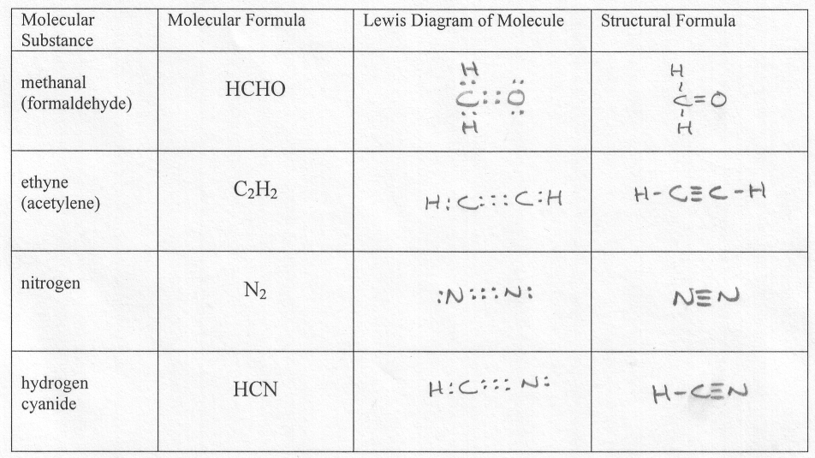

Part B

